## Mission Requirements

For the 2012-2013 Design/Build/Fly competition, the task designated for the teams to accomplish is to build an electric, radio controlled drone. The Drone should be able to complete a series of missions which simulate the following conditions.

* Take-off from a constrained environment
* Perform similar to a stealth drone and carry internal stores of rockets
* Be able to carry varying configurations of payloads and fly stably

Also several design constrains where imposed by the AIAA DBF competition board. These constraints include.

* Electrically powered with a maximum of 20 Amps and powered by a NiMH or NiCad batteries weighing a maximum of 1.5lbs
* Prior to beginning the competition the airplane MUST pass a wing-tip test

After completing the wing-tip test the airplane will be allowed to fly in three series of missions. Each mission has its individual scoring method which will be discussed later.

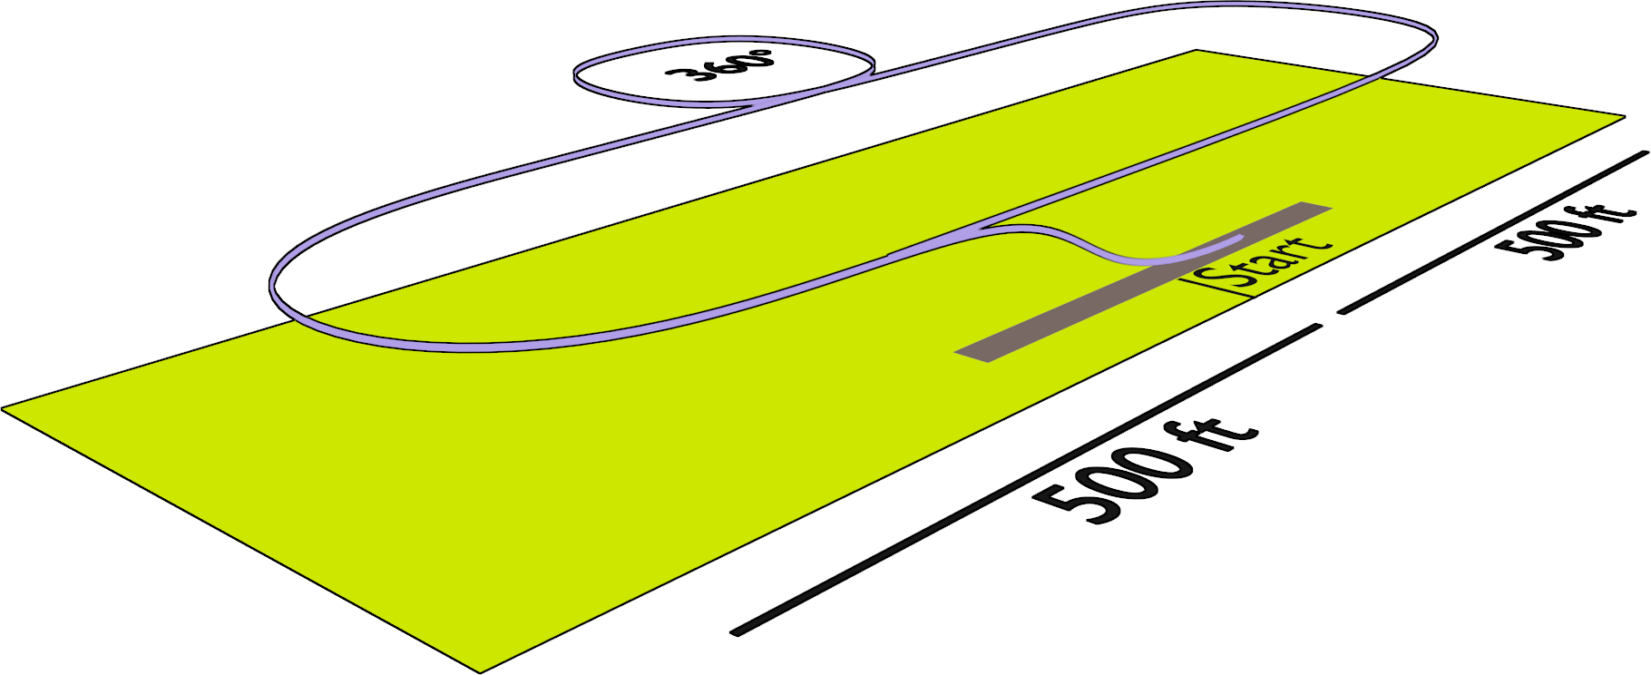

Figure : Flight Course

Table : Mission Requirements

|  |  |
| --- | --- |
| Mission | Objective |
| Short Take-off | * Take-off within 30 ft2 * Complete as many laps as possible in 4 minutes * Must complete a successful landing |
| Stealth Mission | * Take-off within 30 ft2 * Complete 3 laps with a full storage of rockets * Must complete a successful landing |
| Strike Mission | * Take-off within 30 ft2 * Complete 3 laps mixed-stores flight * The mixed stores will picked randomly on the day of the competition * Must complete a successful landing |

### Scoring

$$Overall Score=Report Score×\frac{Total Flight Score}{RAC}$$

Where,

$$Total Flight Score=Mission One Score+Mission Two Score+Mission Three Score$$

$$RAC=\frac{\sqrt{Empty Weight×Size Factor}}{10}$$

Also,

$$Mission One Score=2×\left(\frac{Number of Laps}{Maximum Number of Laps}\right)$$

$$Mission Two Score=4×\left(\frac{Number of Stores}{Maximum Number of Stores}\right)$$

$$Mission Three Score=6×\left(\frac{Fastest Time Flown}{Team Time Flown}\right)$$

$$Size Factor=Plane Length+2×Plane Span$$

Where the Empty Weight is the maximum weight of the aircraft measured before each mission, the size factor is calculated as follows

## Design Requirements derived from Mission Requirements

From the mission requirements the team was able to derive design requirements for each mission. Also scoring is another factor in weighing which design requirements holds a larger weight than the others.

### Mission One Requirements

From the mission description it can be inferred that there are two factors to the design of the aircraft. First is a high lifting airfoil to allow the airplane to take-off quickly. Second is speed, thus choosing a high propulsive system is an important factor for the success of this mission.

### Mission Two Requirements

Having chosen a high lifting airfoil in the first mission to allow for easy and short take-off, the important addition to the design requirements is a large internal carrying capacity. These can be further examined by studying the internal rocket dimensions and designing a fuselage to accommodate them.

### Mission Three Requirements

Mission three includes similar requirements as mission two, which is to hold internal rockets. However there is a further requirement of having a payload on the wings and studying the configurations possible leads to the requirement of having pylons on the wings to hold the rockets.

### Derived Requirement Breakdown

* High lifting airfoil
* High propulsive system
* Fuselage to hold the maximum number of internal rockets
* Pylons to hold rockets on both sides of the fuselage

Also it can be noted you may refer to appendix A for a breakdown of the scoring optimization of each mission.

## Flight Performance

The expected flight performance of the aircraft can be estimated using several formulas. The following table holds all the estimated values of the important factors for our aircraft.

Table : Flight Performance Estimates

|  |  |
| --- | --- |
| Factor | Estimate |
| Takeoff Velocity [ft/s]: | 25.83 |
| Lift Force at Takeoff [lbf]: | 2.39 |
| Takeoff Drag [lbf]: | 0.086 |
| Mean Acceleration [ft/s^2]: | 12.10 |
| Takeoff Distance [ft]: | 19.30 |
| Climb Velocity [ft/s]: | 10.32 |
| Coefficient of Lift at Cruise [lbf]: | 5.51 |
| Velocity at Cruise [ft/s]: | 6.19 |
| Turn Rate [deg/s]: | 247.28 |

## Mission Performance

### Mission One Performance

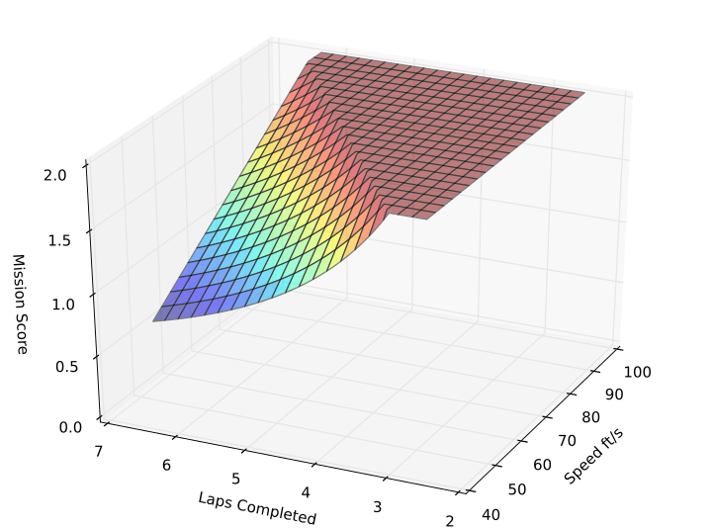

The DBF rules clearly show the length of each lap to be 3800ft, to get a score at least one lap must be completed. This leads to the lower limit of speed we must achieve, 3800/(4*60) = 15.8 ft/s. Afterwards choosing an upper bound of 100 ft/s as a good range to explore. Using this formula plotting a graph with all the factor and then using it do pick a optimal speed for our project.  
  
The plot clearly shows three regions a slope, a ridge, and a plateau each of which is important to be interpreted. The slope highlights the region that the design would be suboptimal; this of course is where the project expects to be because in the plot the assumption of an ideal scenario is used. The plateau region is the area where there is overdesign. Overdesign is bad, due to waste of resources, space, and time. The last region is the ridge; this region is where the slope meets the plateau. This line is very important to any design; this ridge is where the best choice should be when picking a motor for our purposes.

### **Mission Two Performance**

From the plot, it clearly demonstrates that aiming for a range of 2 to 10 rockets is preferable. The primary factor is not weight of the rockets, since the rockets weight 1.3 ounces each. The rockets shape are the issue, each rocket has a shaft of 1 in and 1.5 in fins on 4 sides of the thrust exit. Thus each rocket takes a span of 4 inches, for a drone this is a lot of space.

### Mission Three Performance

Also notice that the fixed value in the scoring is in the numerator this time, thus the fastest time flown is dependent on the score of all teams. This mission is very random, and thus hard to optimize for. This mission has each team carry a random load of rockets; the load will be decided on the day of the competition through a roll of a die. Each number has a specific configuration that we must be capable of carrying. Thus choosing a design parameter to use for mission three is hard. However plotting this score is still very useful because it illustrates how the times will affect our final score.

### Total Score Performance

The last plot that is included is the how the size factor and the empty weight will affect the total final score. For this plot it was necessary to assume a few values for certain parameters to achieve a plot. The values assumed are a total mission score of 6 out of a possible 12 points.

The plot illustrates how the sizing of the airplane affects the overall score. Notice that the plot does not plateau like the previous score; this means that there is always room to improve on our score by reducing the weight and reducing the size of the aircraft.